# Description:

An analog clock is displayed with present time and date display.

Clock runs on system date and time and re-synchronizes time every second without keeping processor to check system time every clock cycle (Using delay function).

There is also a close button to close current figure of clock.

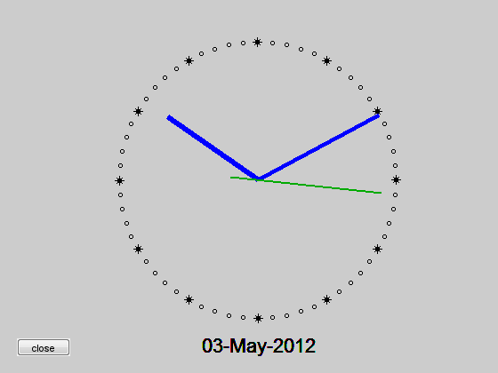

# Inbuilt Functions Used

1. CLF Clear current figure.

CLF deletes all children of the current figure with visible handles.

CLF RESET deletes all children (including ones with hidden handles) and also resets all figure properties, except Position, Units, PaperPosition and PaperUnits, to their default values.

1. SHG Show graph window.

SHG brings the current figure window forward.

1. AXIS Control axis scaling and appearance.

AXIS([XMIN XMAX YMIN YMAX]) sets scaling for the x- and y-axes on the current plot.

AXIS([XMIN XMAX YMIN YMAX ZMIN ZMAX]) sets the scaling for the x-, y- and z-axes on the current 3-D plot.

AXIS([XMIN XMAX YMIN YMAX ZMIN ZMAX CMIN CMAX]) sets the scaling for the x-, y-, z-axes and color scaling limits on the current axis.

AXIS SQUARE makes the current axis box square in size.

AXIS OFF turns off all axis labeling, tick marks and background.

AXIS ON turns axis labeling, tick marks and background back on.

1. UICONTROL Create user interface control.

UICONTROL('PropertyName1',value1,'PropertyName2',value2,...) creates a user interface control in the current figure window and returns a handle to it.

UICONTROL properties can be set at object creation time using PropertyName/PropertyValue pair arguments to UICONTRO

1. CLOCK Current date and time as date vector.

C = CLOCK returns a six element date vector containing the current time and date in decimal form:

[year month day hour minute seconds]

The sixth element of the date vector output (seconds) is accurate to several digits beyond the decimal point. FIX(CLOCK) rounds to integer display format.

1. TEXT Text annotation.

TEXT(X,Y,'string') adds the text in the quotes to location (X,Y) on the current axes, where (X,Y) is in units from the current plot. If X and Y are vectors, TEXT writes the text at all locations given. If 'string' is an array the same number of rows as the length of X and Y, TEXT marks each point with the corresponding row of the 'string' array.

1. SET Set object properties.

SET(H,'PropertyName',PropertyValue) sets the value of the specified property for the graphics object with handle H. H can be a vector of handles, in which case SET sets the properties' values for all the objects.

1. PAUSE Wait for user response.

PAUSE(n) pauses for n seconds before continuing, where n can also be a fraction.

1. CLOSE Close figure.

CLOSE(H) closes the window with handle H.

1. GCF Get handle to current figure.

H = GCF returns the handle of the current figure. The current figure is the window into which graphics commands like PLOT, TITLE, SURF, etc. will draw.

# References:

1. <http://www.mathworks.com/matlabcentral/fileexchange>